File #_____________
JOHNSON CHIROPRACTIC HEALTH & WELLNESS
REGISTRATION & HISTORY
INSURANCE INFORMATION
Who is responsible for this account?__________________________ Relationship to Patient_____________________
Insurance Co._______________________________________ Group #_______________________________________
Subscriber’s Name____________________________________ Birthdate_____________________ SSN____________
Additional or Secondary Insurance? Yes_____ No_____
Secondary Insurance Co.___________________________________ Group #__________________________________
ASSIGNMENT AND RELEASE
I certify that I, and/or my dependent(s), have insurance coverage with_________________________________________________
and assign directly to Todd D. Johnson D.C., F.A.S.F.A. all insurance benefits, if any, otherwise payable to me for services rendered. I understand that I am financially responsible for all charges whether paid by insurance or not. I authorize the use of my signature on all insurance submissions. Dr. Johnson D.C., F.A.S.F.A., may use my health care information and may disclose such information to Dr. Johnson’s Insurance Company(ies) and their agents for obtaining payment for services and determining insurance benefits or the benefits payable for related services. This consent will end when my current treatment plan is completed or one year from the date signed.
______________________________________________ ________________________ Date__________
Print Name of Patient/Parent/Guardian/Personal Representative Signature
ACCIDENT INFORMATION
Is condition due to an accident? Yes_____ No_____ Date_____ Type of accident-Auto_____ Work_____ Home_____ Other____
To whom have you made a report of your accident?___________ Auto Insurance-Employer____ Worker____ Comp____ Other___
Attorney Name (if applicable)______________________________________ Phone Number___________________________________
PATIENT INFORMATION
PLEASE PRINT Date_______________________ SSN_____________________________________________
Patient Name___________________________________________ Is Patient Under 18? Y_____ N_____
Parent/Guardian__________________________________________________________________________________
Mailing Address__________________________________ City_________________________ State_____ Zip________
Residential Address_______________________________ City_________________________ State_____ Zip________
Email________________________________________________
PHONE NUMBERS
Cell Phone (_____)____________ Home Phone (_______)___________ Work Phone (_______)___________
Best time and place to reach you______________________ Emergency Phone (_____)____________
Emergency Contact_________________________________ Relationship____________________________________
Sex M_____ F_____ Age_____ Birthdate____________
Married_____ Widowed_____ Single_____ Minor_____ Separated_____ Divorced_____ Partnered for_____years
Patient Employer/School_____________________________________________Occupation_____________________
Mailing Address__________________________________ City_________________________ State_____ Zip________
Spouse’s Name_______________________________________ Birthdate_____________________ SSN____________
Spouse’s Employer_____________________________ Work Phone #_______________________________ Ext_____
How Did You Hear About Us?______________________

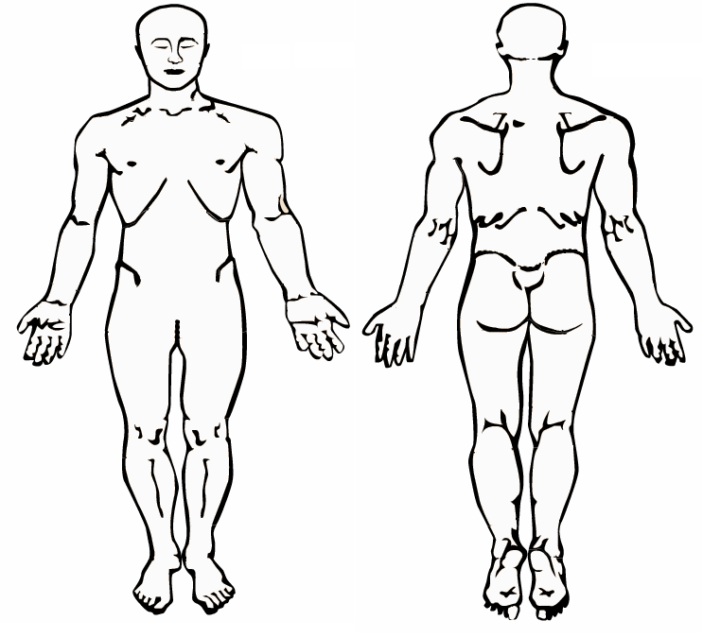
PATIENT REASON FOR VISIT
Reason for Visit_____________________________________________________________________________________
When did your symptoms appear?______________________________________________________________________
Is this condition getting progressively worse? Yes_____ No______ Unknown_____
Rate the severity of your pain on a scale from 1 (least pain) to 10 (severe pain) _______
Type of pain:
Sharp___ Dull___ Throbbing___ Numbness___ Aching___ Shooting___
Burning___ Tingling___ Cramps___ Stiffness___ Swelling___ Other___
How often do you have this pain?_______________________________________________________________________
Is it constant or does it come and go?____________________________________________________________________
Does it interfere with:
Work_____ Sleep_____ Daily Routine_____ Reaction________________________________
Activities or movements that are painful to perform:
Sitting_____ Standing_____ Walking_____ Bending_____ Lying Down_____

Mark and X on the picture where you continue to have pain, numbness, or tingling.

HEALTH HISTORY
What treatment have you already received for you condition?
Medications______ Surgery______ Physical Therapy______ Chiropractic Services______ None______ Other______
Who has treated you for your condition:
Doctor Name________________________ Office Name_____________________________
Office Address__________________________________ City_________________________ State_____ Zip________
Doctor Name________________________ Office Name_____________________________
Office Address__________________________________ City_________________________ State_____ Zip________

Date of Last:
Physical Exam________ Spinal X-Ray________ Blood Test________ Spinal Exam________
Chest X-Ray________ Urine Test________ Dental X-Ray________ MRI/CT-Scan________ Bone Scan________

Place a mark on “Yes” or “No” to indicate if you have had any of the following:
Yes___ No___ AIDS/HIV Yes___ No___ Chicken Pox Yes___ No___ Liver Disease
Yes___ No___ Rheumatoid Arthritis Yes___ No___ Alcoholism Yes___ No___ Diabetes
Yes___ No___ Measles Yes___ No___ Rheumatic Fever Yes___ No___ Allergy Shots
Yes___ No___ Emphysema Yes___ No___ Migraine Headaches Yes___ No___ Scarlet Fever
Yes___ No___ Anemia Yes___ No___ Epilepsy Yes___ No___ Miscarriage
Yes___ No___ Stroke Yes___ No___ Anorexia Yes___ No___ Fractures
Yes___ No___ Mononucleosis Yes___ No___ Suicide Attempt Yes___ No___ Appendicitis
Yes___ No___ Glaucoma Yes___ No___ Multiple Sclerosis Yes___ No___ Thyroid Problems
Yes___ No___ Arthritis Yes___ No___ Goiter Yes___ No___ Mumps
Yes___ No___ Tonsillitis Yes___ No___ Asthma Yes___ No___ Gonorrhea
Yes___ No___ Osteoporosis Yes___ No___ Tuberculosis Yes___ No___ Bleeding Disorders
Yes___ No___ Gout Yes___ No___ Pacemaker Yes___ No___ Tumors/Growths
Yes___ No___ Breast Lump Yes___ No___ Heart Disease Yes___ No___ Parkinson’s Disease
Yes___ No___ Typhoid Fever Yes___ No___ Bronchitis Yes___ No___ Hepatitis
Yes___ No___ Pinched Nerve Yes___ No___ Ulcers Yes___ No___ Bulimia
Yes___ No___ Hernia Yes___ No___ Pneumonia Yes___ No___ Vaginal Infections
Yes___ No___ Caner Yes___ No___ Herniated Disk Yes___ No___ Polio
Yes___ No___ Venereal Disease Yes___ No___ Cataracts Yes___ No___ Herpes
Yes___ No___ Prostate Problem Yes___ No___ Whooping Cough Yes___ No___ Chemical Dependency
Yes___ No___ High Cholesterol Yes___ No___ Prosthesis Yes___ No___ Kidney Disease
Yes___ No___ Psychiatric Care Yes___ No___ Other
MEDICATIONS
Name of Medication Dosage Amount Prescribing Doctor
_______________________________________________________________________________________________
_______________________________________________________________________________________________
_______________________________________________________________________________________________
_______________________________________________________________________________________________
ALLERGIES
_______________________________________________________________________________________________
_______________________________________________________________________________________________
VITAMINS / HERBS / MINERALS
_______________________________________________________________________________________________
_______________________________________________________________________________________________

Pharmacy Name_____________________________________ Pharmacy Phone_______________________________
INJURIES/SURGERIES DESCRIPTION DATE
Falls:___________________________________________________________________________________________
Head Injuries:____________________________________________________________________________________
Broken Bones:___________________________________________________________________________________
Dislocations:_____________________________________________________________________________________
Surgeries:_______________________________________________________________________________________
Other:__________________________________________________________________________________________
WHAT ARE YOU DOING FOR YOUR INJURIES:
_______________________________________________________________________________________________
_______________________________________________________________________________________________
_______________________________________________________________________________________________
WHAT HAS WORKED BEST FOR YOU:
_______________________________________________________________________________________________
_______________________________________________________________________________________________

Are you pregnant? Yes_____ No_____ Due Date__________
PATIENT CONDITION
Place a mark on “Yes” or “No” to indicate if you have had any of the following:
EXERCISE WORK ACTIVITY HABITS
_____ None _____Sitting _____Smoking _______________Packs/Day
_____ Moderate _____Standing _____Alcohol _______________Drinks/Weeks
_____ Daily _____Light Labor _____Coffee/Caffeine _______________Drinks Cups/Day
_____ Heavy _____Heavy Labor _____High Stress Level _______________Reason

TREATMENTS/SERVICES/PRODUCTS INTERESTED IN OR WOULD LIKE TO FIND OUT MORE ABOUT:

_____ Chiropractic _____ Consultation for Treatment Options
_____ Medical Wave Pressure Therapy _____Sports Physicals
_____ Ultrasound Therapy _____Stretching / Strengthening Exercises
_____ Electrical Muscle Stimulation Therapy _____Heat / Cold Therapy
_____ Acupuncture _____Physiotherapy
_____ Postual ReEducation _____Itersegmental Traction Therapy
_____ Massage Therapy _____ Reflexology / Soft Tissue Trigger Point Release
_____ Chronic Pain Education _____ CBD Oil
_____ Nutrition Supplements _____ Health and Wellness Aids and Products
_____ Diet / Nutrition Counseling _____ Diabetic Education
NOTES:

TODD D. JOHNSON D.C., F.A.S.F.A.
CONFIDENTIAL PATIENT INFORMATION

CONSENT FOR EXAMINATION, X-RAYS, AND CHIROPRACTIC SERVICE
I consent to have a complete examination performed to determine if my condition may be considered for chiropractic care.
I agree to bring any x-rays films, ordered elsewhere for this clinic shall become a part of this clinic’s professional records and shall be subject solely to the control and disposition of the doctor.
I also give consent to Dr. Todd Johnson D.C., F.A.S.F.A., to administer whatever treatment or therapeutic procedures or devices as deemed necessary to treat my condition.
The doctor will go over my examination and/or x-ray results during the follow-up appointment to answer any questions I may have.
I acknowledge that no guarantee or assurance of the results of treatment can be given to me by the above attending chiropractor, associate or assistants.
Signature___________________________________ Date__________ Witness__________________________________

PARENT/GUARDIAN COMPLETE ONLY IF TREATMENT FOR A MINOR CHILD
I hereby authorize the doctor of Johnson Chiropractic Health Center to administer procedures, as outlined above, for my son/daughter/other.
Name of Child: First___________________________________ MI_____ Last____________________________________
Parent/Guardian Signature: ____________________________________ Print___________________________________
JOHNSON CHIROPRACTIC HEATLTH AND WELLNESS
FINNCIAL RESPONSIBILITY

Johnson Chiropractic Health and Wellness accepts Cash, Personal Checks, Visa, Mastercard and Discover as payments for services. Please remember, it is the patients responsibility to know what their insurance benefits are and if a referral is needed to see our provider. If you have any concerns regarding your insurance coverage, please call the number on the back of your card for a full explanation of your coverage. Our financial policy is as follows:

- Insurance Co-Payments: Must be paid at the time services are rendered.
- Deductibles/Co-Insurance: If your deductible has not been met full payment of the services rendered will be required at the time of service along with any applicable co-insurance amounts until your deductible has been met.
- Private Pay/Non-Contracted Insurance Companies: If you do not have insurance coverage or have coverage with an insurance we are not contracted with, you will be responsible for making payment in full or making payment arrangements.
- Collection Policy: If your account is placed with a collection agency, all future visits would require payment in full at the time of service. You will be held fully accountable for any collection agency fees and/or attorney fees that are acquired in the recovery of this debt. These fees are over and above the original balance due.
- Returned Checks: A $35.00 fee will be added to your account for any returned checks.
- No Show Appointments: There will be a $25.00 fee charged to any account for no show appointments.

It is very important to stay informed about your insurance coverage. If you have a new insurance, it is your responsibility to provide an updated card. You will be responsible for the total amount of any unpaid claims that are denied for incorrect insurance information.

Signature:___________________________________________________________________________ Date:__________

PRIVACY NOTICE
THE FOLLOWING NOTICE DESCRIBES HOW YOUR MEDICAL INFORMATION MAY BE USED AND DISCLOSED AND HOW YOU CAN GET ACCESS TO THIS INFORMATION. PLEASE REVIEW THE FOLLOWING INFORMATION CAREFULLY AND SIGN BELOW.
YOUR CONFIDENTAL HEALTHCARE INFORMATION
- May be released to other healthcare professionals within the facility for providing you with quality healthcare.
- May be released to your insurance provider for receiving payment for healthcare services.
- May be released to public or law enforcement officials in the event of an investigation in which you are a victim of abuse, a crime or domestic violence.
- May be released to other healthcare providers in the event you need emergency care.
- May be released to a public health organization or federal organization in the event of a communicable disease or to report a defective device or untoward event to a biological product (food or medication)
- May not be released for any other purpose that which is identified in this notice.
- Johnson Chiropractic Health and Wellness is required by law to protect the privacy of its patients. We will keep confidential all patient healthcare information and will provide patients with a list of duties or practices that protect confidential healthcare information. We will abide by the terms of this notice. We reserve the right to make changes to this notice.
- You have the right to complain to Johnson Chiropractic Health and Wellness if you believe your rights to privacy have been violated. All complaints should be mailed to Johnson Chiropractic Health and Wellness. All complaints will be investigated. No personal issue will be raised for filing a complaint.

For Further information about this Privacy Notice please contact: Johnson Chiropractic Health and Wellness
I AUTHORIZE __________ I DO NOT AUTHORIZE__________
Patient Signature:__________________________________________________________________ Date Signed:_______

